1. Connect to the server
2. Download mysql work branch

* <https://dev.mysql.com/downloads/workbench/>
* Skip login by clicking **No thanks, Just…**
* When its installed open the application
* Click on the **MySQL Connections**

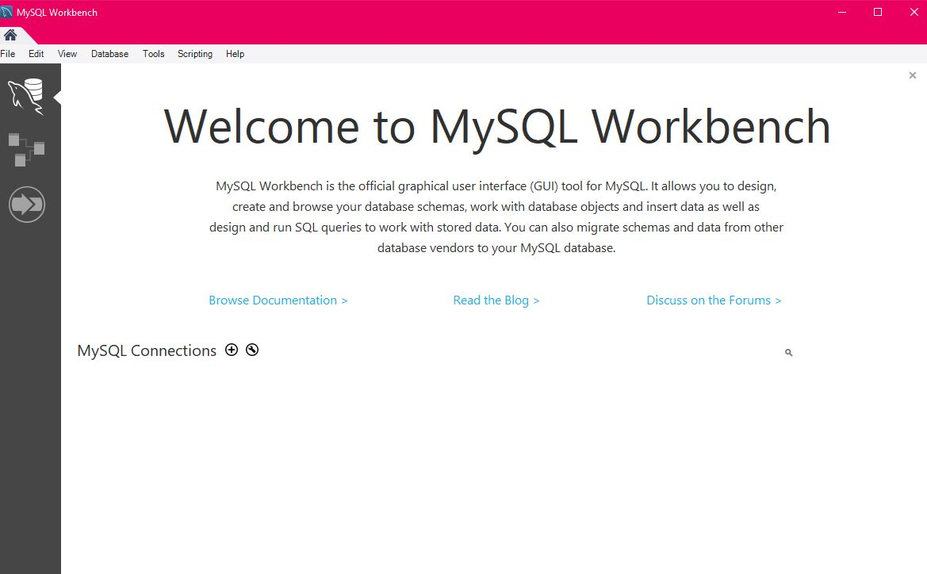

* Fill out the Connection Name
* Type “34.227.118.133” in **Hostname** box
* 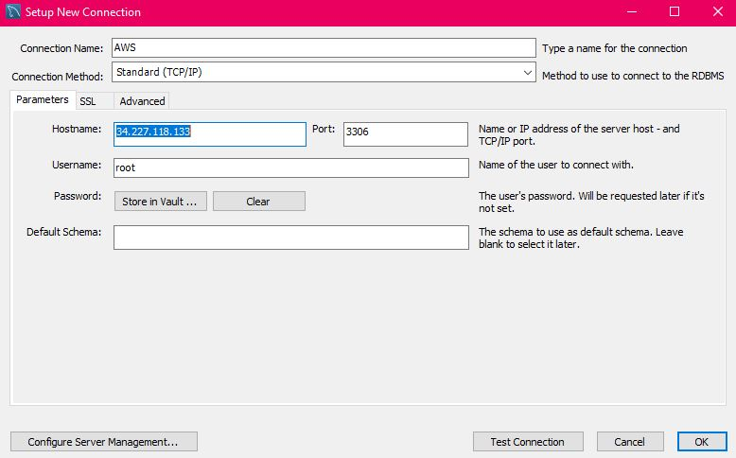
* Click on the **Store in Vault..**
* Type“team15” in the **password** section

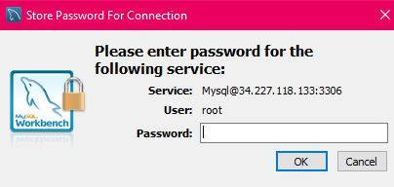

* Click on **test connection**

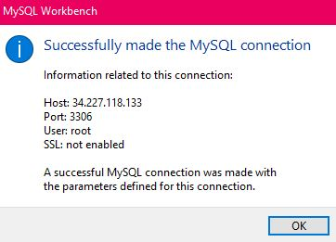

* Click ok
* You have connection to AWS MySQL

